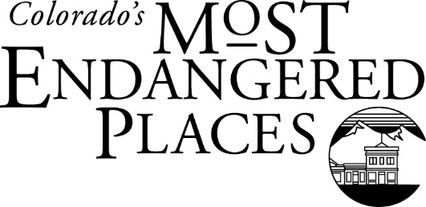Click or tap here to enter text.

Please complete the form below and attach additional sheets. No materials submitted with the application will be returned. Submission of this application grants Colorado Preservation, Inc permission to include these items in any brochures/promotional materials prepared for/by Colorado Preservation, Inc.

Yes

No

Unknown

List all groups/individuals nominating the site: Click or tap here to enter text.

Check if you would like to keep this information confidential.

Unknown

No

Yes

If yes, does the owner endorse this application?

Unknown

Publicly Owned

Privately Owned

Has this site been previously nominated to the Endangered Places Program?  Yes  No  Unknown

National Register of Historic Places

Is the owner of the property aware of this? nomination?

Has this site been given historic designation? (Check more than one if applies)

Nominated by (Name): Click or tap here to enter text.

Organization: Click or tap here to enter text.

Address: Click or tap here to enter text.

Town/City: Click or tap here to enter text.

Email: Click or tap here to enter text.

Phone Number: Click or tap here to enter text.

Phone Number: Click or tap here to enter text.

Email: Click or tap here to enter text.

Town/City: Click or tap here to enter text.

Address: Click or tap here to enter text.

Property Owner (Name): Click or tap here to enter text.

Other: Click or tap here to enter text.

Unknown

Not Designated

Contributing to a Local, State, or National Historic District

Local Landmark

State Register of Historic Places

County: Click or tap here to enter text.

Town/City: Click or tap here to enter text.

Property Address: Click or tap here to enter text.

Historic/Current Site Name: Click or tap here to enter text.



NOMINATIONS DUE AUGUST 16, 2019!

**NOMINATOR INFORMATION**

**SITE INFORMATION**

**OWNER INFORMATION**



*This project was partially funded by a grant from History Colorado’s State Historical Fund.*

**TO SUBMIT - Mail or email by August 16, 2019**

*Attention: Kim Grant*

1420 Ogden Street, Suite #104, Denver, Colorado 80218

[***kgrant@coloradopreservation.org***](mailto:lrieke@coloradopreservation.org)

***303-893-4260, ext. 222***

Please note reviewers will be assigned to this nomination by the **end of September** and you should be notified by **December** if your nomination has been officially selected.

**Please make sure to include the following information with your nomination:**

* Map and directions to the site
* At least 3 current photographs (digital format preferred)
* Historic photographs if available
* At least 3 letters of support for the site.

1. When was the resource constructed?
2. Please describe the history of the resource – why it is significant to your community and Colorado. Please include specific associated themes (for example, transportation, homesteading, mining, etc.).
3. Please provide a current description of the resource and its condition. Make sure to discuss its current use, ownership and surrounding landscape. If vacant please list for approximately how long.
4. Why is the resource endangered and how immediate is the threat?
5. Have any measures been taken to protect the resource? If yes, please explain.
6. Is their community support for the resource? Please explain.
7. Are you aware of any opposition to saving the resource? Are you aware of any opposition to listing the resource as one of Colorado’s Most Endangered Places? If yes, please explain.
8. To the best of your knowledge, has the resource received financial assistance (for example grant funding, foundation support, governmental funding, preservation tax credits, etc.)? If yes, please explain.
9. Why should Colorado Preservation, Inc select this resource as one of Colorado’s Most Endangered Places? How would listing benefit the site?
10. How would listing benefit and/or strengthen CPI’s Endangered Places Program? For example, what lessons could be learned by listing this resource, what partnerships could be gained, what can it contribute to the story of Colorado’s development and heritage?
11. What are the short and/or long-term plans for the site?
12. If selected, what defines a SAVE for this site and what are the steps to bring about this save?
13. If selected, what assistance would you look to receive from Colorado Preservation, Inc?
14. Please provide any additional information that will help the Endangered Places Program Review Committee understand why this site is a strong candidate for the program and should be selected.



Please provide contact information for local media outlets (television, radio, web, print, etc.)

Please provide information on any identified future funding, partners, and/or potential sponsors

Check here to acknowledge your understanding that participation in Colorado’s Most Endangered Places Program includes an expectation of future site mentorship and participation (whenever possible) in shared knowledge events such as Endangered Places sessions and workshops at the Saving Places Conference.

**PLEASE USE ADDITIONAL SHEETS TO ANSWER THE FOLLOWING**